**Task 3B : Theme & Rulebook Questionnaire**

|  |  |
| --- | --- |
| **Team ID** | LS_3083 |
| **College** | MBM ENGINEERING COLLEGE |
| **Team Leader** | AJEET JAIN |
| **e-mail** | jainajeet29@gmail.com |
| **Date** | 29 NOVEMBER 2023 |

| **Question No.** | **Max. Marks** | **Marks Scored** |
| --- | --- | --- |
| Q1 | 5 |  |
| Q2 | 10 |  |
| Q3 | 5 |  |
| Q4 | 5 |  |
| Q5 | 10 |  |
| Q6 | 5 |  |
| Q7 | 10 |  |
| Q8 | 15 |  |
| Q9 | 5 |  |
| Q10 | 5 |  |
| Q11 | 10 |  |
| Q12 | 5 |  |
| Q13 | 10 |  |
| **Total** | 100 |  |

**Q1.** Briefly describe your experience in building the Lunar Scout bike.

**A1. When we started working on task 1 to balance inverted pendulum**

**I was thinking, it is impossible for me but after spending a lot of hours**

**It seems possible to me still we don’t know solutions but we got a hope**

**To get success in the task then we stared writing code in CoppeliaSim**

**And got some positive output . I knew that my K matrix is perfect because**

**I followed every steps correctly and calculate the L equation 3 4 times**

**Then after checking a lot of function I got solution to find error in states**

**At first there was nothing to check then these errors are correct but when**

**I started finding input torque using K matrix and error I found that pendulum is balancing and then I use all the permutation of sign in formula and got one pair working well at starting but after some movement it got unbalanced so I started working of changing gain of errors and after a lot of tuning I got a perfect solution for that task and a lot of knowledge about Rotary inverted pendulum and LQR Control System. Now I had good knowledge of these things and task 2 released**

**I started working immediately first I went through post of task 2 a lot of time in day and starded designing bike as a gif was uploaded on the post**

**of bike that was made of using 2 cuboid then I thought I should use the same and I made the same bike but when I started working on it I got to know that I have to calculate everything again for new shapes . so I designed my bike again using cylinder and mass distributed according to task 1 pendulam centre of mass and then changed only mass values in octave program to find k matrix and in only 2 days I got success in task 2.**

**But when I run the task2b evaluator I got 0 marks then I posted this on Q&A then got replay that check again and try but I didn’t get any marks again . so I started working on task2c and got full marks in a day then I posted again that I got full marks in task2c but 0 in task2b then after 2 days I got a mail that there was a bug in evaluator now use version 2 and then I got marks and completed the task2 and got 1 rank in leader board that gave me a lot of confidence and this journey was Awesome .**

--------------------------------------------------------------------------------------------------------

**Q2.** In task 1, you were introduced to LQR controller design for a simple pendulum and asked to do mathematical modelling and LQR controller design for Rotary Inverted Pendulum. In that, you were asked to derive the equations, linearize around the equilibrium point and find the A & B matrix using the Jacobian function.

In this question, you have to choose the states for your Lunar Scout bike that you are going to design. Model the system using Euler-Lagrangian Mechanics that you learned in task 1. Linearize the system using jacobians around the equilibrium points representing your physical system. Use mathematical expressions for derivations and proper diagrams where necessary.

**A2.**

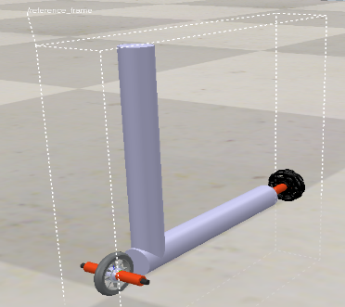

**This is my bike and mathematical expressions and calculation I will do on paper and uplod scaned images.**

[**PDF LINK 🔗**](https://drive.google.com/file/d/1Z-dA45QYkaZ2wgy460Ks06teq-79r6cE/view?usp=drivesdk)

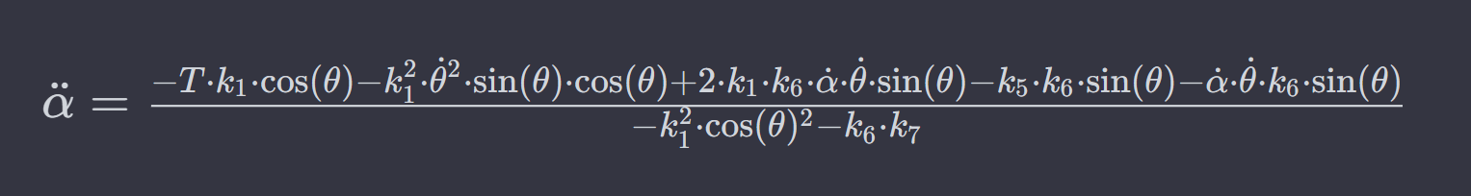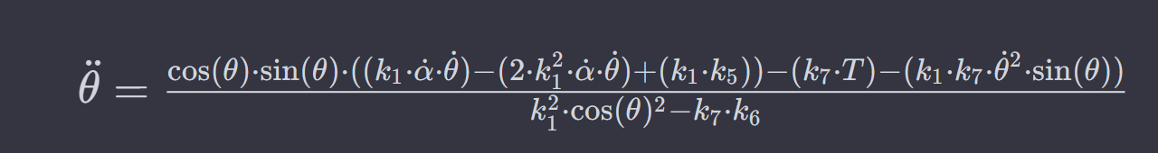

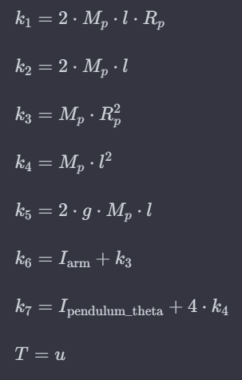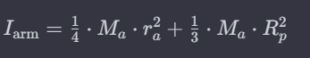

**then I used jacobian and subs function in octave to find A and B matrix at equilibrium point {alpha_dot,alpha,theta_dot,theta}= {0,0,0,pi}**

--------------------------------------------------------------------------------------------------------

**Q3.** Which is the most optimal controller between PID and LQR. Justify your answer.

**A3. Acording to me it totally depends on what is our need both controllers have their own strengths and weaknesses. LQR control gives good performance but it is more complex and other side PID is easy but give less performance and need to do lot of tuning for good performance . PID control is good choice for simple application but for complex and non linear behaviour LQR is optimal controller and in my point of view LQR is best for our project it will give best performance. Ease of implementation**

**of PID is easy but for LQR it is complex.But if we have to choose one of them I will go for LQR it gives all calculated values and don’t need more tuning after calculation only need to change gains according to our need.**

--------------------------------------------------------------------------------------------------------

**Q4.** What is the significance of finding Controllability and Observability of a system in state space approach?

**A4. Controllability refers to the ability to control the system’s state using inputs. The significance of finding the Controllability is it shows that we can control the system’s states as our desired point in a finite time and it confirms that our system is controllable by inputs. Controllability is essential for ensuring that the system can be guided to achieve desired performance or behavior.**

**Observability is the ability to find out what’s happing inside the system .**

**If we want to know current states by examining its output then Observability is significant for this.**

--------------------------------------------------------------------------------------------------------

**Q5.** Briefly explain your opinion on having the centre of mass of the bike low or high. Use diagrams/calculations/examples to support your argument.

**A5. According to me lower centre of mass makes it more difficult to move away from equilibrium point of bike and makes it more stable less responsive and other side higher centre of mass makes it less stable more responsive. When I was doing task 2b and working on mass distribution I tried every location of centre of mass and after doing a lot of experiment I got the result that when I put COM higer my bike goes immediately to yaw setpoint but then It got unbalanced and starts vibrating and when I put COM lowest bike remains stable but less responsive it takes more time to reach desired yaw point and after a lot of practicals I got a perfect location of COM that was not more lower and not higher it was In middle of both of these position and according to me it is due to Gravity Torque.**

**Let’s understand with simple example of a truck (transport Vehicle) we can take it as a inverted pendulum on a banked turn then there will be high chances of getting turning(crashing) of the fully loaded truck because having COM high.**

**For keeping up right position of bike lower COM is good but for controlling bike with keeping position up right then position of COM should be at middle of higer and lower position .**

**Example of truck was suitable for keeping the up right position stable.**

**But now other side balancing the stick on hand is second example to understand controlling as we know practically balancing a pen on hand is much harder then balancing a big heavy stick on hand.**

**So according to me position of centre of mass should at a suitable position to make balancing and controlling both at a time.**

--------------------------------------------------------------------------------------------------------

**Q6.** In what cases will the run time be considered as the maximum time (Tmax = 300 seconds) according to the scoring formula and theme rules?

**A6.** **According to the theme rules, the run time will be considered as the maximum time (Tmax = 300 seconds) in the following cases:**

1. **Invalid Run Completion:**

**If the 5-second Buzzer beep, indicating run completion, occurs without the bike reaching any of the three Start/Stop Locations (SL) or without covering all given Colony Sites (CS), the run time will be considered as the maximum time.**

**2. Exceeding Maximum Manual Interventions (MI):**

**If the team exceeds the maximum allowed Manual Interventions (MI) during the run (more than 5 MIs), the run will end, and the time taken will be considered as the maximum time.**

**In both cases, the competition considers the run as incomplete or invalid, and the time taken is capped at the maximum time limit of 300 seconds (Tmax).**

--------------------------------------------------------------------------------------------------------

**Q7.** Explain what you have understood from the Theme play in your own words.

**A7. According to theme description each team will perform different tasks according to an undisclosed configuration table. Each team will go to the same colony sites but polarities of magnet will be different for each team in colony site. Polarities of magnet facing path will be considered to detect by bike. Obstacle configuration will be same for each team. There will be three locations S1 ,S2 and S3 . One of them will be start location and one of them will be stop location this will be disclosed in configuration table. There will be six colony sites and each site will have a permanent magnet placed with a random polarity. There will be maximum three obstacles on the path bike has to balance from passing by obstacles. At first bike will be placed at the start location according to given position in configuration table. Then one member will turn on the bike. It will start balancing at its position on two point of contact with ground. After starting bike a buzzer will beep for one second it will indicate the timer has been started the team will select a member before run to control the bike using remote made by them bike should be balanced all the time including the time of detection or indication while navigating through the arena track bike will stop at colony sites for at least three seconds halt and Generate one second bazaar beep twice with delay of one second along with indicating polarity of magnet for 3 seconds using led red colour for North polarity the (dmaged colony sites) green colour for South polarity (not damage colony sites). When all colony sites will be covered bike should reach to stop location and trigger the Bazar beep for 5 seconds and this will be considered as run completion time.**

--------------------------------------------------------------------------------------------------------

**Q8.** What will be the SCORE in the following situation:  
**Given Run Configuration:**  
StartLocation : S1  
ColonySites: 1, 2, 3, 5  
Obstacle: O1, O3

In the given run there are four Colony Sites(**CS**). The bike started its journey from S1. It halted near the first CS, which has the north pole of the magnet facing the track. It indicated green LED and buzzer, then started its traversal.

* Now it has reached the second CS which has no magnet in it. It doesn’t indicate any of the light and started its traversal .
* The bike crossed one obstacle and then indicated the first CS again with red led and buzzer with proper halt, then it continued forward.
* Now it reaches its final CS which is having a south pole facing towards the track and indicating green LED and buzzer beep while passing by the CS, but without halting near the CS.
* Bike then goes to the S2 position, stops and beeps the buzzer for 5 seconds. By this time 150 seconds have passed, from the start time. The bike did not have any MI/PP/HP during the run.

**A8.** **Start Location : S1**

**Colony Sites: 1, 2, 3, 5**

**Obstacle: O1, O3**

**According to given information**

**CV=2**

**WI = 2**

**CI = 2**

**OB = 1**

**T = 150**

**MI = 0**

**HP = 0**

**PP = 0**

**RB = 0**

**Total Score = (300-T) + CV *75 + CI*150 - WI*50 - MI*25 - HP*20 - PP*10 + OB*50 + RB*100 + DB**

**Total Score = (300-150) + 2 *75 + 2*150 - 2*50 - 0*25 - 0*20 - 0*10 + 1*50 + 0*100 + DB**

**Total Score = 550 + DB**

--------------------------------------------------------------------------------------------------------

**Q9.** What is Parallel and Perpendicular axis theorem? Is it required for mathematical modelling? Justify your answer with respect to the lunar scout bike.

**A9.** **The Parallel Axis Theorem and the Perpendicular Axis Theorem are two related principles in physics and engineering, specifically in the context of rotational motion and the calculation of moments of inertia.**

**1. Parallel Axis Theorem:**

**- The Parallel Axis Theorem states that the moment of inertia of a rigid body about any axis parallel to an axis through its center of mass is the sum of the moment of inertia of the body about its center of mass and the product of its mass and the square of the distance between the two axes.**

**2. Perpendicular Axis Theorem:**

**- The Perpendicular Axis Theorem is a special case of the moment of inertia theorem and is applicable for planar objects (objects lying in a plane). It states that the sum of the moments of inertia of a planar object about any two perpendicular axes in the plane of the object is equal to the moment of inertia about an axis perpendicular to the plane and passing through the point of intersection of the two perpendicular axes.**

**These theorems are valuable tools in solving rotational motion problems, especially when dealing with complex shapes or objects with irregular geometries like lunar scout bike. They provide a way to calculate the moment of inertia about an axis that does not pass through the center of mass, making it easier to analyze and solve rotational motion equations.**

**Yes, it is required for mathematical modelling of lunar scout bike.**

**The moment of inertia about the end of the cylinder is**

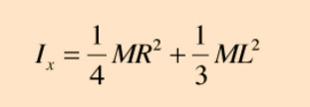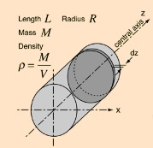

**The development of the expression for the moment of inertia of a cylinder about a diameter at its end (the x-axis in the diagram) makes use of both the parallel axis theorem and the perpendicular axis theorem.**

**As bike is working on concept of RIP (rotary inverted pendulum) and the arm is connected from its end to the pivot and it rotates with respect to end of cylinder so to find the moment of inertia of a cylinder about a diameter at its end we use both these theorem.**

**These images are from** [**🔗**](http://hyperphysics.phy-astr.gsu.edu/hbase/icyl.html#icyl4)

--------------------------------------------------------------------------------------------------------

**Q10.** How will you check whether the system is stable or not in a state-space approach?

**A10. In state-space approach we can find system is stable or not at each of the equilibrium points by finding out the eigenvalues of the State matrix(A matrix). If any of the eigenvalues have a positive real part, the system will be unstable and if all real part of eigenvalues are negative then system will be stable.**

--------------------------------------------------------------------------------------------------------

**Q11.** What will be happening in the following situation:

The bike wrongly indicated the LED colour for a colony site while in halt. When starting to move it crosses the dotted line and hits the colony sites and falls. So Manual intervention has taken place. How many penalties will be imposed and what are they?

**A11. There will be 2 penalties:-**

**1.Wrong Indication Penalty (WI):**

**The bike wrongly indicated the LED color for a Colony Site while in halt.**

**This incurs a Wrong Indication Penalty (WI).**

**2.Manual Intervention Penalty (MI):**

**The bike crosses the dotted line, hits the Colony Sites, and falls.**

**A Manual Intervention (MI) has high weightage so This incurs a Manual Intervention Penalty (MI).**

**Because In the case of an event incurring multiple penalties(any of MI/HP/PP), the penalty with highest weight among them will be considered for that particular event.**

**Here all three penalties happened (MI/HP/PP)but MI has high weightage so only MI will be counted.**

--------------------------------------------------------------------------------------------------------

**Q12.** How many different type sensors does a 6-axis Inertial Measurement Unit(IMU) have? Explain what physical quantities they measure exactly?

**A12. There are two types of sensors does a 6-axis Inertial Measurement Unit(IMU)**

1. **Accelerometers (3-axis): These sensors measure linear acceleration along three perpendicular axes: X, Y, and Z. This allows the IMU to determine the translational motion of the object it is attached to, such as its acceleration, deceleration, and tilt.**
2. **Gyroscopes (3-axis): These sensors measure the angular velocity of the object, also known as its rotational motion around the three axes: pitch, roll, and yaw. This allows the IMU to determine the object's orientation and angular rate of change in its orientation.**

**Therefore, 6-axis IMU measures a total of 6 physical quantities:**

**3 linear accelerations: X, Y, and Z**

**3 angular velocities: pitch, roll, and yaw**

**MPU6050 Accelerometer and Gyroscope Module,** **GY-87(3-axis Gyro+Acceleration) measures 6-axis Inertial Measurement Unit(IMU)**

--------------------------------------------------------------------------------------------------------**Q13.**  Consider a wheeled inverted pendulum having a vertical body balanced using a DC geared motor. The center of mass of the body is at 5 cm height from the axle of the wheel and motor shaft. The diameter of the wheel is 4 cm.

* What is the torque required from the DC geared motor(max RPM = 300), to be able to balance this body of total mass 1.5 kg(consider wheel & motor massless), with max correctable angular tilt as +/- 5 degrees.

(Mention steps for your calculation)

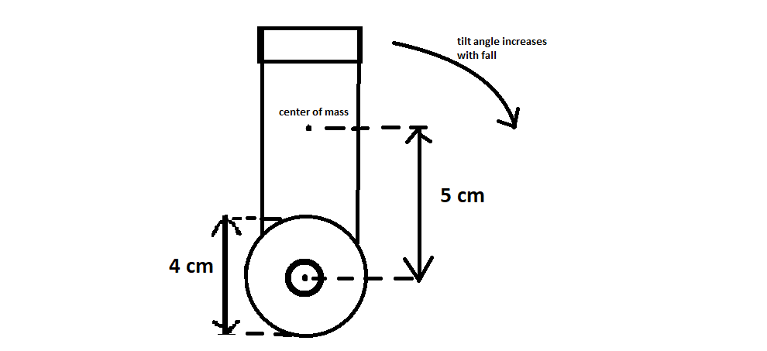

**A13.**

**ANSWER PDF** [**🔗**](https://drive.google.com/file/d/1dZqPUybc1-9ggH4X-F26R_EQhnEiAuz6/view?usp=drivesdk)

**DC motor have to apply the torque of equal in magnitude of body’s applied torque and in opposite direction to balance the body vertical. Calculations are in provided pdf.**

--------------------------------------------------------------------------------------------------------